Name:

ID:

Submit here: <https://docs.google.com/forms/d/e/1FAIpQLSdb6qnfclbXkjpCQiW_ePKJ8LxNRVQfdOTBYRdcqlbZuwCUEA/viewform>

Challenge 05

PART 1:

1. Consider the following:

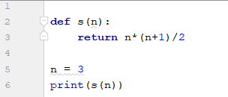

* What is **s(15)**?

|  |  |
| --- | --- |
| 15 | 105 |
| 120 | 6 |
| 3 | 100 |

1. Consider the following:

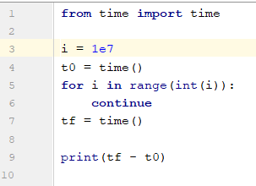

* What happens to tf-t0 as i gets larger?

|  |  |
| --- | --- |
| Gets smaller | Gets larger |
| Nothing | Error |

* Which of the following best describes the code?

|  |  |
| --- | --- |
| Loop through 10 million integers | Use the continue keyword to create an infinite loop |
| Prints the difference between two complex numbers | Runs a large for loop and calculates the difference between two integers |
| Outputs the time required to run a for loop | Converts the complex number 1e7 to an integer |

1. Consider the following:

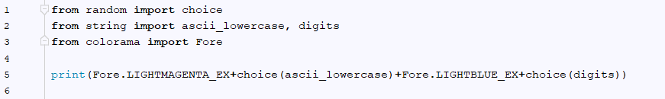

* Which of the following is a possible output?

|  |  |
| --- | --- |
| m50 | Y0 |
| A7 | l0 |
| A17 | A70 |
| a1 | z10 |

1. Consider the following:

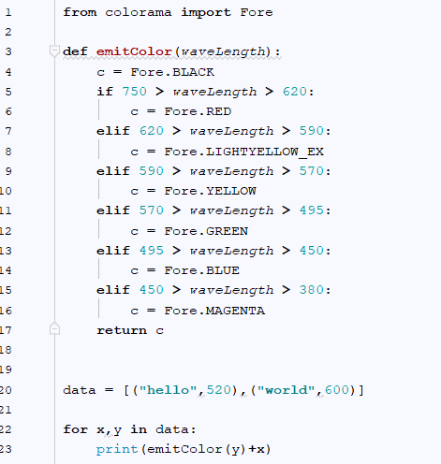

* Change data so that the output becomes (type answer below):



Part 2: [Lists](https://runestone.academy/runestone/books/published/thinkcspy/Lists/intro-Lists.html)

1. How are strings different than lists? (10.1)
2. What type of data are the elements in the following list: (10.2)



1. Evaluate the following: (10.3)

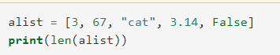

1. Evaluate the following: (10.4)



1. Evaluate the following: (10.5)

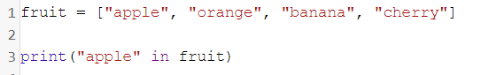

1. Evaluate the following: (10.5)

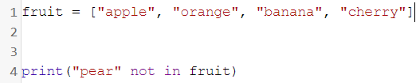

1. Evaluate the following: (10.6)

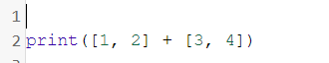

1. Evaluate the following: (10.6)



1. Consider the following: (10.7)

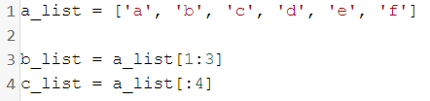

* What is len(b_list)